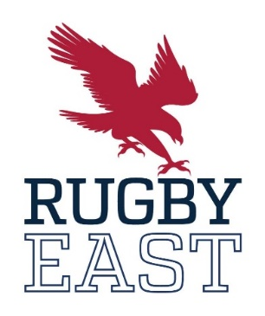
All Conference Fall 2022
First Team
1 | William Webb | Navy |  | Sophomore
2 | Marshall Frank | Queens |  | Senior
3 | Larry Williams | Army |  | Senior
4 | Richard Rose | St. Bonaventure |  | Senior
5 | Ben Richards | Army |  | Junior
6 | Prince-Louis Bush | Queens |  | Senior
7 | Jack McMahon | Navy |  | Senior
8 | Ben Haugh | Navy |  | Junior
9 | Tiaan Mosconi | Army |  | Junior
10 | Dalton Musselman | Penn State |  | Senior
11 | Fadzai Mushonga | Notre Dame College |  | Senior
12 | Lewis Gray | Navy |  | Senior
13 | Mate Kvirikashvili | Kutztown |  | Junior
14 | Logan Bachman | Kutztown |  | Junior
15 | Roanin Krieger | Navy |  | Freshman
Second Team
1 | John O'Toole |  | Penn State |  | Senior
2 | Max Brown |  | Army |  | Senior
3 | Joe Hawthorne |  | St. Bonaventure |  | Senior
4 | Campbell Halloran |  | Penn State |  | Senior
5 | Chester Stanyon |  | Queens |  | Sophomore
6 | Dom Tianga |  | Army |  | Junior
7 | Matthew Conroy |  | St. Bonaventure |  | Junior
8 | Lucas Pattinson |  | Army |  | Junior
9 | Hilton Olivier |  | Queens |  | Junior
10 | Lachlan McDonald |  | Notre Dame College |  | Freshman
11 | Michael Golden |  | Southern Virginia |  | Junior
12 | Keelin Coyle |  | St. Bonaventure |  | Senior
13 | Campbell van Rooyen |  | Queens |  | Junior
14 | Ultan Horrigan |  | St. Bonaventure |  | Senior
15 | Mathew Joss |  | St. Bonaventure |  | Senior

Honorable Mention
 | Adam Bazan | Army | Senior
 | Cameron Giwa-McNeil | Mary Washington | Sophomore
 | Cameron Thurtell | Kutztown | Sophomore
 | Connor Foster | Mary Washington | Sophomore
 | Giancarlo Nastasi | Penn State | Senior
 | Hayden McKay | Mount St. Mary's | Freshman
 | Hugh Johnston | Notre Dame College | Senior
 | Hunter Danesi | Virginia Tech | Junior
 | Ian Roudybush | Penn State | Junior
 | Jack Aleman | Navy | Junior
 | Jude Fanmeyer | Mount St. Mary's | Junior
 | Lloyd Stephens | Mary Washington | Junior
 | Lukas Duhigg | Notre Dame College | Senior
 | Lukas Otineru | St. Bonaventure | Sophomore
 | Nate Gould | Army | Sophomore
 | Nick Ball | Mary Washington | Freshman
 | Nick Janowsky | Navy | Junior
 | Nick Masterson | Penn State | Junior
 | O'Shea Settle | Southern Virginia | Sophomore
 | PJ O'Reilly | Kutztown | Senior
 | Raymond McGettigan | Mount St. Mary's | Senior
 | Tanner Russell | Navy | Sophomore
 | Tanner Smith | Notre Dame College | Sophomore
 | Vaughn Schmitz | Navy | Junior
 | Will Richey | Virginia Tech | Junior
 | William Stanton | Southern Virginia | Sophomore

